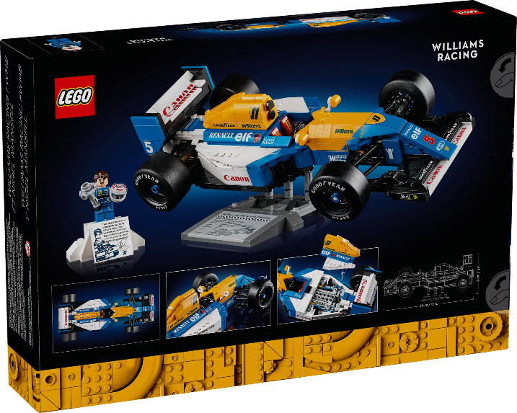****

**Product details**

**LEGO F1 Car**

**Price: $49.99**

**Experience the speed, precision, and thrill of Formula 1 with LEGO's authentic design.**

**Authentic Formula 1 car design**

**The LEGO F1 Car is a must-have for motorsport and LEGO enthusiasts. It features a stunning, authentic design inspired by the world of Formula 1 racing. The set is perfect for both play and display, delivering a thrilling and immersive building experience**

.

**THANK YOU!**

**WELLCOME TO OUR WEBSITE**